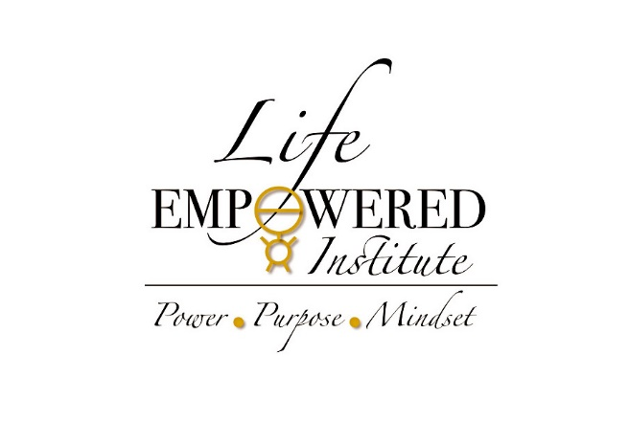
Knowing This Can Change Everything!
https://youtu.be/2aaCC8EV444
It Works
https://youtu.be/Fiv2J1eITdM
I Am Affirmations
https://youtu.be/GnWlERK0UJc
I am that, I am Wayne Dyer 2015
https://youtu.be/HiTtEQ_X2o8
Dr. Wayne Dyer “I AM THAT I AM” meditation
https://youtu.be/A96OI4b8sFY
Morning Motivation – What Successful People Do In the First 8 Minutes of Their Day
https://youtu.be/5diEq1gTE4Y

